



LINUX LABORATORY-LECTURE-1211-ENCS3130



**Name: Amany Khdair partner: Hadeel Abdellatif**

**Id: 1190728 Id: 1190451**

**Instructor: Dr. Hanna Bullata**

**Assistant: Ms. Kati Sadi**

**Section: 3**

* 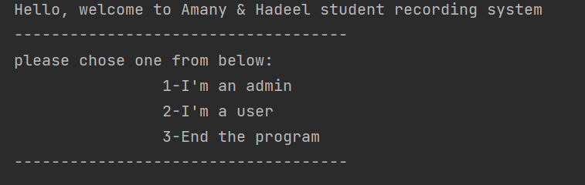**User interface:**
* 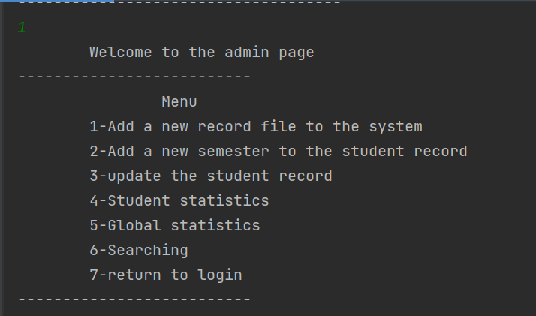**Admin options:**
* 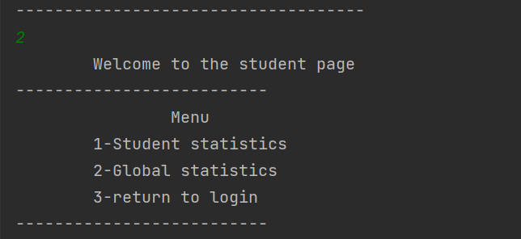**Student options:**
* **Admin options starting with the first option:**

When enter a student id exist in the system, massage error will show as below ⬇

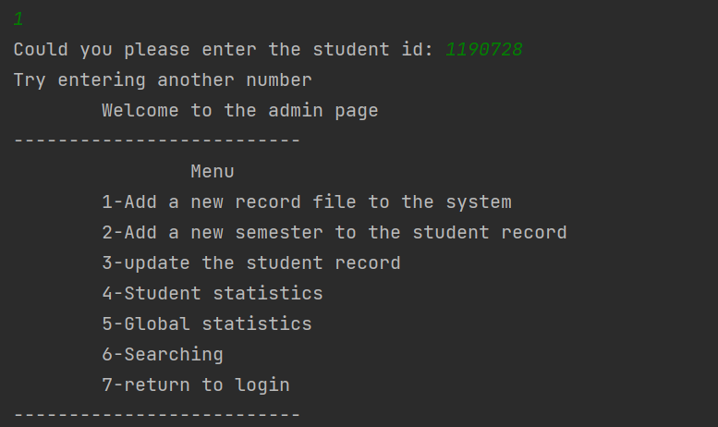

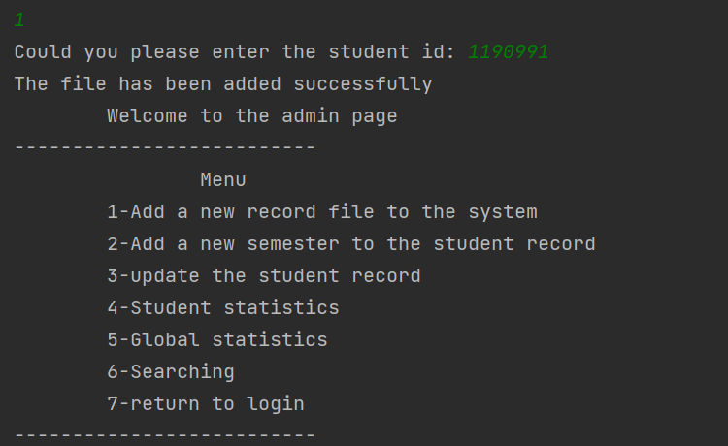While when entering a non-exist id then⬇

**Result:**



* 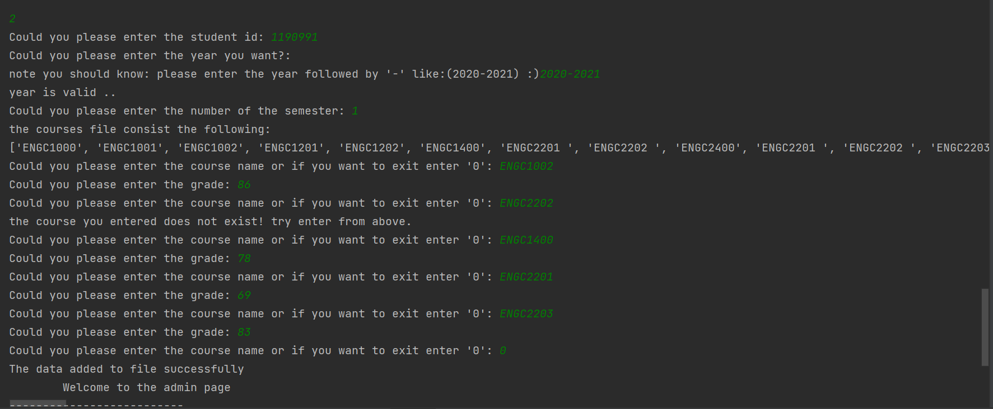**Admin options 🡪 second option:**

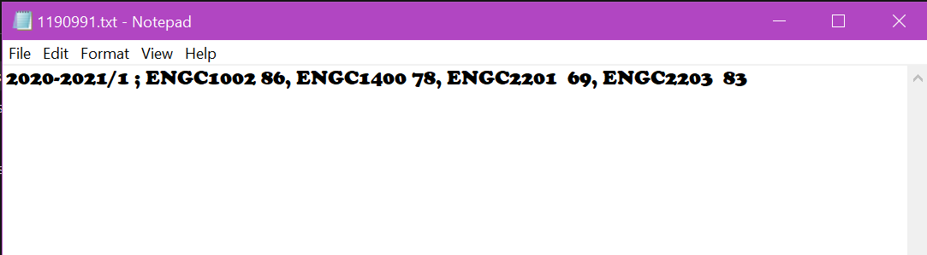**Result:**

But when entering an id does not exist in the system ⬇

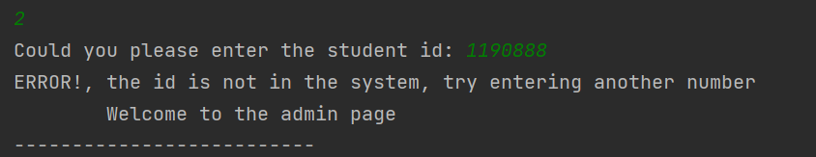

* 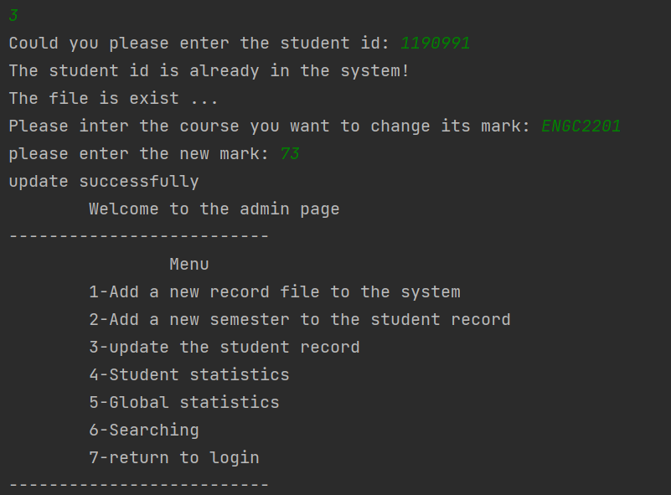**Admin options 🡪 third option:**

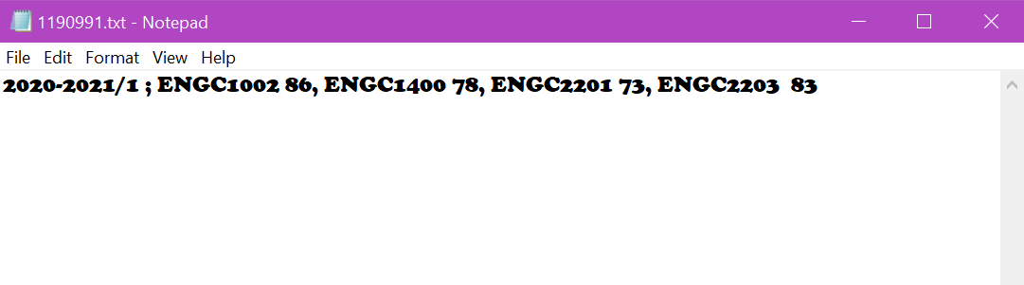**Result:**

* **Admin options 🡪 fourth option:**

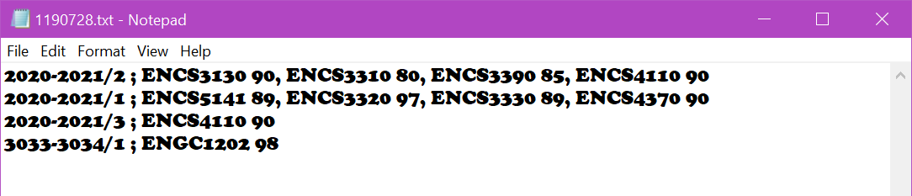Let us try another student who have the following data ⬇:

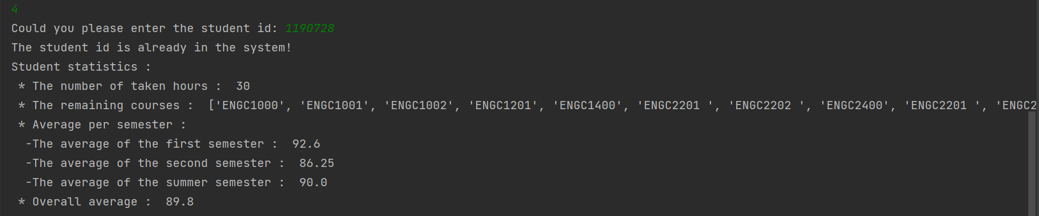

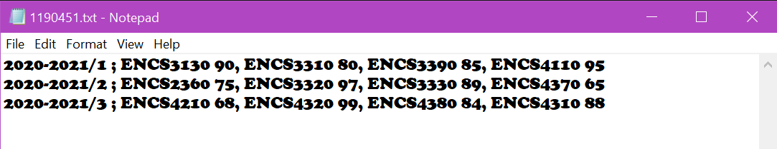**Another student:**

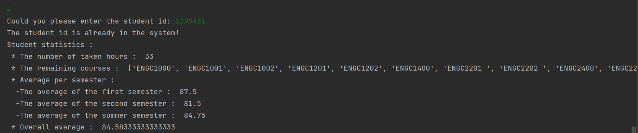

* 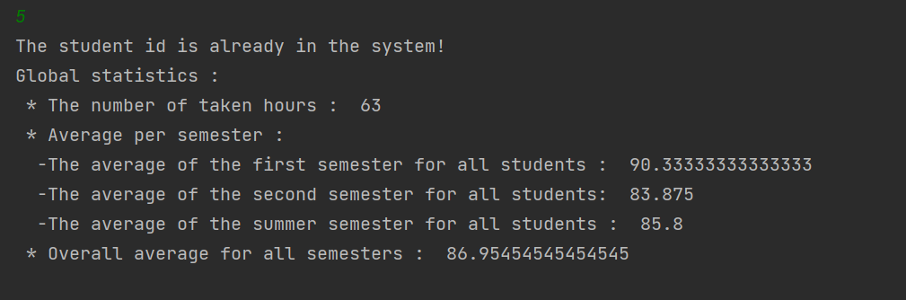**Admin options 🡪 fifth option:**

**For the graph:**

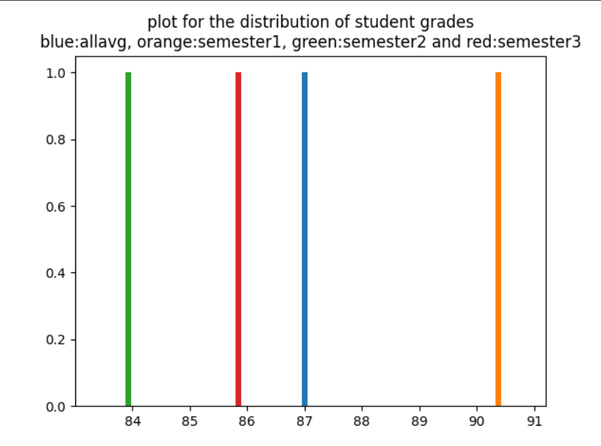

* 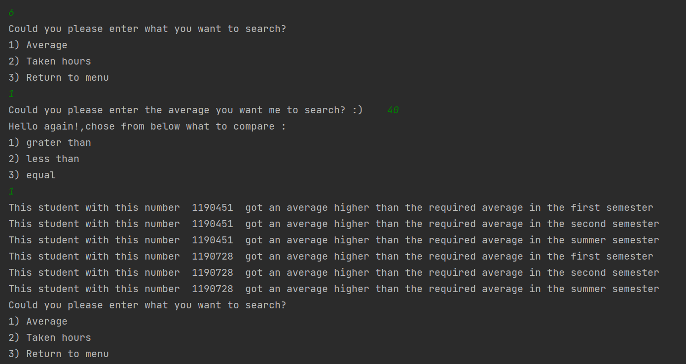**Admin options 🡪 sixth option:**

Here I chose to search about the average and grater than 40. Same for other options.

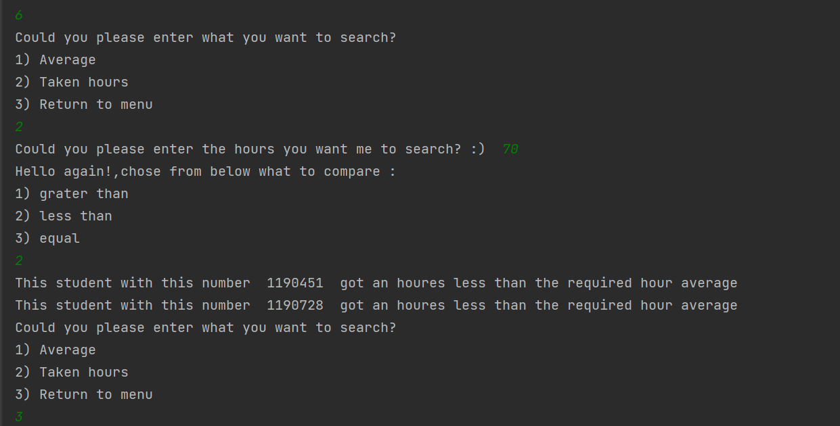Let’s see the taken hours:

* 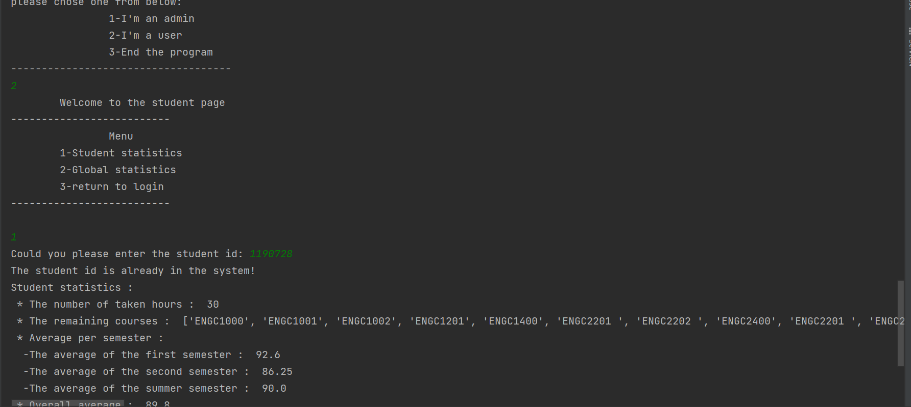**Student options 🡪 first option:**
* 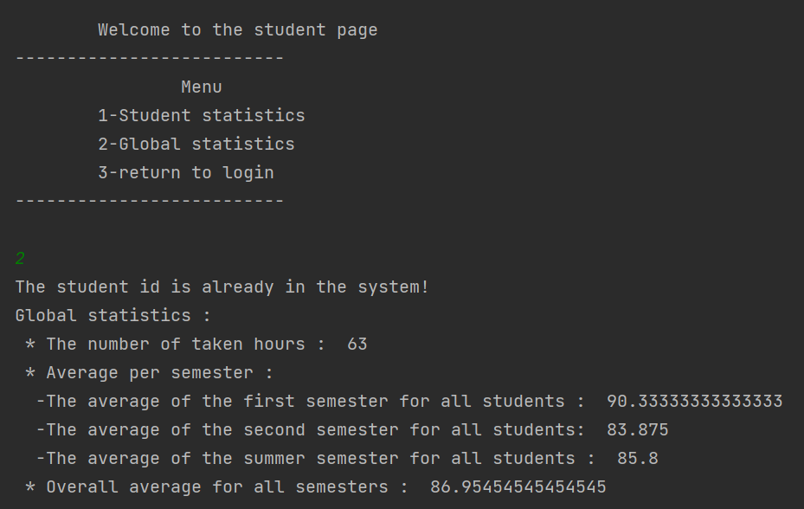**Student options 🡪 second option:**

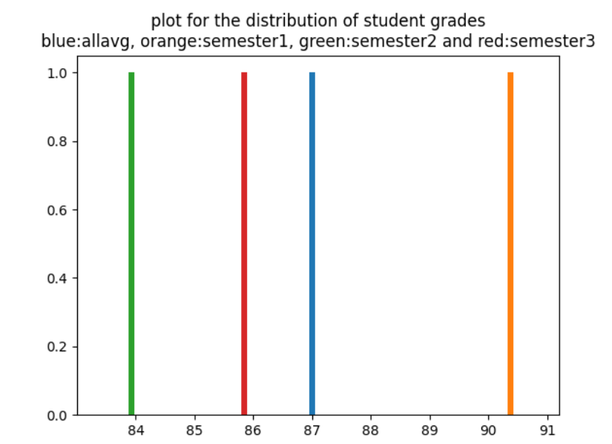And the graph printed before will be printed here too:

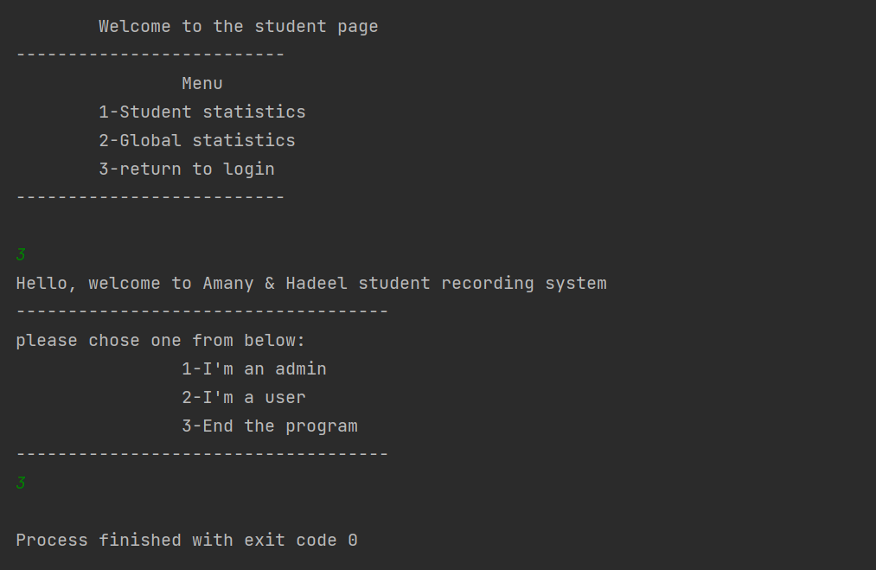return to login page and end the program ⬇